

**Travel Guide**

By

**Anamika Das**

**ID: 161-35-1440**

A project report submitted in partial fulfillment of the requirement for the degree of

Bachelor of Science in Software Engineering

**Department of Software Engineering**

**Daffodil International University**

Spring –2020

Copyright © 2020 by Daffodil International University

# Approval

This project titled on “**Travel Guide**”, submitted by **Anamika Das** (**ID: 161-35-1440**) to the Department of Software Engineering, Daffodil International University has been accepted as satisfactory for the partial fulfilment of the requirements for the degree of Bachelor of Science in Software Engineering and approval as to its style and contents.

**BOARD OF EXAMINERS**



--------------------------------------------------------- **Chairman**

**Prof. Dr. Touhid Bhuiyan**

**Professor and Head**

Department of Software Engineering

Faculty of Science and Information Technology

Daffodil International University



--------------------------------------------------------- **Internal Examiner 1**

**Dr. Md. Asraf Ali**

**Associate Professor**

Department of Software Engineering

Faculty of Science and Information Technology

Daffodil International University



--------------------------------------------------------- **Internal Examiner 2**

**Asif khan Shakir**

**Lecturer (Senior Scale)**

Department of Software Engineering

Faculty of Science and Information Technology

Daffodil International University

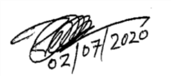

--------------------------------------------------------- **External Examiner 2**

**Prof. Dr. Mohammod Abul Kaashem**

**Professor**

Department of Computer Science and Engineering

Dhaka University of Engineering and Technology, Gazipur

# Declaration

It hereby declares that this project has been completed by me under the supervision of **Dr. Md Mostafijur Rahman, Associate Professor, Department of Software Engineering, and Daffodil International University**. It is also declared that neither this work nor any part of this has been submitted elsewhere for award of any degree or diploma by me.

**Submitted by:**



Anamika Das

Student ID: 161-35-1440

Batch: 19th

Department of Software Engineering

Faculty of Science & Information Technology

Daffodil International University

**Certified by:**



Dr. Md Mostafijur Rahman

Associate Professor

Department of Software Engineering

Faculty of Science & Information Technology

Daffodil International University

# Acknowledgement

First of all, I am grateful to The Almighty Allah for making me eligible to complete this work. After that I would like to thank my supervisor Dr. Md Mostafijur Rahman, Associate Professor, Department of Software Engineering. I am extremely thankful to his skill, sincere and valuable guidance and encouragement extended to me. I would like to express my heartiest thanks to Dr. Touhid Bhuiyan, professor & head of Software Engineering department for his continuous encouragement. I also would like to thank all the faculty members of the Department of Software Engineering for their assistance & encouragement. Last but not least, I would like to thank to my parents for their unconditional support and love.

# Abstract

“Travel Guide” this is an online based travel guide taking system. It helps traveler to get their travel guide through internet by using website. This project is helpful for user who doesn’t waste their time to get their desire jobs as a travel guide. It is also useful for tour and tourism event organizer or company to get their client. All types of users can easily login from this site, and travelers can send request to hire travel guide by providing their own requirements. Travel guides can to response a request at a time in according with their choice. Tour organizers can create tour events or packages without trouble. Admin can monitor registered users as needed, approve events which are created by organizer or company for showing on traveler screen. This website another benefit is traveler who books package not only one organizer or company same packages but other organizer or company packages also see by searching. All of users are able to update their profile information.

**Table of Contents**

**Approval** i

**Declaration** ii

**Acknowledgement** iii

**Abstract** iv

**Chapter One**

Introduction 1

1.1 Overview 1

1.2 Purpose 1

1.3 Background 1

1.4 Objectives 2

1.5 Stakeholder 2

1.5.1 Internal Stakeholder 2

1.5.2 External Stakeholder 2

1.6 Proposed System 3

1.7 Project Plan 4

1.8 Gantt chart 5

1.9 Risk 5

1.10 Milestone 6

**Chapter Two**

Software Requirement Specification 7

2.1 Requirement satisfaction 7

2.2 Functional requirement 7

2.2.1 User Registration 7

2.2.2 User Login 8

2.2.3 Hire Travel Guide 8

2.2.4 Accept Hiring Request 9

2.2.5 Create Tour Event 9

2.2.6 Approve Tour Event 10

2.2.7 Show and Booking Tour Package 10

2.2.8 Monitoring System 11

2.3 Performance Requirement 11

2.3.1 Speed and Latency Requirement 11

2.3.2 Legibility and accuracy requirements 12

2.3.3 Capacity requirements 12

2.3.4 Dependability requirements 13

2.3.5 Reliability and availability 13

2.3.6 Safety critical requirements: 13

2.4 Maintainability and supportability 14

2.4.1 Supportability requirements specification 14

2.5 Adaptability requirements 14

2.5.1 Security requirements 14

2.5.2 Access requirements 15

2.5.3 Integrity requirements 15

2.6 Usability and human integrity requirements 15

2.7 Data Validation 15

2.8 User Interface Design 15

**Chapter Three**

Software Requirement Analysis 16

3.1 Use Case Diagram: 16

3.1.1 Registration 18

3.1.2 Login 18

3.1.3 Hire Guide 19

3.1.4 Get Hiring Request 19

3.1.5 Accept Hiring Request 20

3.1.6 Search package 20

3.1.7 Show package 21

3.1.8 Booking package 21

3.1.9 Get Booking Information 22

3.1.10 Create package 22

3.1.11 Approve package 23

3.2 Activity Diagram 24

3.2.1 Registration 24

3.2.2 Login 25

3.2.3 Hire Travel Guide 26

3.2.4 Get and Accept Hiring Request 27

3.2.5 Search and Show Package 28

3.2.6 Booking Package 29

3.2.7 Get Booking Information 30

3.2.8 Create Package 31

3.2.9 Approve Created Package 32

3.3 Sequence Diagram: 33

3.3.1 Registration: 33

3.3.2 Login: 34

3.3.3 Hire Travel Guide: 35

3.3.4 Booking Package: 36

3.3.5 Get and Accept Hiring Request: 37

3.3.6 Get Booking Information: 38

3.3.7 Create Tour Package: 39

3.3.8 Approve Created Package: 40

3.3.9 Monitor User Information: 41

3.4 Class Diagram: 42

3.5 Entity Relationship Diagram: 43

**Chapter Four**

Technology and Tools 44

4.1 User Interface Technology 44

4.1.1 Technology 44

4.1.2 Tools 44

4.2 Database Technology 44

4.2.1 Technology 44

4.2.2 Tool 44

**Chapter Five**

Implementation 45

5.1 Hardware & Software Specifications 45

5.1.1 Hardware Requirements 45

5.1.2 Software Requirements 45

**Chapter Six**

User Manual 46

6.1 Home Page 46

6.2 Registration 46

6.3 Login 47

6.4 About 47

6.5 Contract 48

6.6 Hire Guide 48

6.7 Accept Hire Request 49

6.8 Create Tour Event 49

6.9 Approve Created Event 50

6.10 Show and Booking Package 50

6.11 User Booing Information 51

6.12 Help 51

6.13 User Information 52

**Chapter Seven**

System Testing 53

7.1 Testing 53

7.2 Testing Strategy 53

7.3 Test approach 53

7.3.1 Black Box Testing 54

7.3.2 White Box Testing 54

7.4 Pass / Fail Criteria 54

7.5 Testing Environment 55

7.6 Use Case Testing 55

7.7 Test Case 55

7.7.1 Test case for User Registration 56

7.7.2 Test Case for User Login 58

7.7.3 Test Case for Hire Travel Guide 60

7.7.4 Test Case for Booking Package 62

7.7.5 Test Case for Accept Request 64

7.7.6 Test Case for Create Tour Package 66

7.7.7 Test Case for Approve Tour Package 68

7.8 Test Report 70

**Chapter Eight**

Conclusion 71

8.1 Project Summary 71

8.2 Limitations 71

8.3 Future Improvement 71

References 72

**List of Figures**

**Chapter One: Introduction**

Figure 1.1: Propose System Model 3

Figure 1.2: Gantt chart 5

**Chapter Three: Software Requirement Analysis**

Figure 3.1: Use Case Diagram 17

Figure 3.2: Activity Diagram of Registration 24

Figure 3.3: Activity Diagram of Login 25

Figure 3.4: Activity Diagram of Hire Travel Guide 26

Figure 3.5: Activity Diagram of Accept Hiring Request 27

Figure 3.6: Activity Diagram of Search and Show Package 28

Figure 3.7: Activity Diagram of Booking Package 29

Figure 3.8: Activity Diagram of get Booking Information 30

Figure 3.9: Activity Diagram of Create package 31

Figure 3.10: Activity Diagram of Approve Package 32

Figure 3.3.1: Registration of Sequence Diagram……………………………….……33

Figure 3.3.2: Login of Sequence Diagram 34

Figure 3.3.3: Sequence Diagram of Hire Travel-Guide 35

Figure 3.3.4: Sequence Diagram of Booking Package 36

Figure 3.3.5: Get and Accept Hiring Request 37

Figure 3.3.6: Get Booking Information of Sequence Diagram 38

Figure 3.3.7: Create Tour Package of Sequence Diagram 39

Figure 3.3.8: Sequence Diagram of Approve Created Package 40

Figure 3.3.9: Sequence Diagram of Monitor User Information 41

Figure 3.4.1: Class Diagram……………………………………………………….....42

Figure 3.5.1: Entity Relationship Diagram………………………………………..…43

**Chapter Six: User Manual**

Figure 6.1: UI Design of Home Page 46

Figure 6.2: UI Design of Registration Page 46

Figure 6.3: UI Design of Login Page 47

Figure 6.4: UI / UX Design of About Page 47

Figure 6.5: UI / UX Design of Contract Page 48

Figure 6.6: UI / UX Design of Hire Guide Page 48

Figure 6.7: UI / UX Design of Accept Hire Request Page 49

Figure 6.8: UI / UX Design of Create Tour Event Page 49

Figure 6.9: UI / UX Design of Approved Event Page 50

Figure 6.10: UI / UX Design of Show and Booking Page 50

Figure 6.11: UI / UX Design of User Booking Information Page 51

Figure 6.12: UI / UX Design of Help Page 51

Figure 6.13: UI / UX Design of User Information Page 52

**List of Tables**

**Chapter One: Introduction**

Table 1.1: Project Plan 4

Table 1.2: Project Milestone 6

**Chapter Two: Software Requirement Specification**

Table 2.1: User Registration 7

Table 2.2: Discuss About User Login 8

Table 2.3: Discuss About Hire Travel Guide 8

Table 2.4: Discuss About Accept Request 9

Table 2.5: Discuss About Create Tour Event 9

Table 2.6: Discuss About Approve Event 10

Table 2.7: Discuss About Booking Tour Package 10

Table 2.8: Discuss About Monitoring System 11

Table 2.9: Discuss About Speed and Latency Requirement 11

Table 2.10: Discuss About Legibility and Accuracy 12

Table 2.11: Explain on Capacity Requirements 12

Table 2.12: Explain on Reliability and Availability 13

**Chapter Three: Software Requirement Analysis**

Table 3.1: Use Case Description of Registration 18

Table 3.2: Use Case Description of Login 18

Table 3.3: Use Case Description of Hire Guide 19

Table 3.4: Use Case Description of Get Hiring Request 19

Table 3.5: Use Case Description of Accept Hiring Request 20

Table 3.6: Use Case Description of Search Package 20

Table 3.7: Use Case Description of Show package 21

Table 3.8: Use Case Description of Booking Package 21

Table 3.9: Use Case Description of Get Booking Information 22

Table 3.10: Use Case Description of Create Package 22

Table 3.11: Use Case Description of Approve Package 23

**Chapter Seven: System Testing**

Table 7.7.1: Test case for User Registration (Pass) 56

Table 7.7.2: Test case for User Registration (Fail) 57

Table 7.7.3: Test Case for User Login (pass) 58

Table 7.7.4: Test Case for User Login (Fail) 59

Table 7.7.5: Test Case for Hire Travel Guide (Pass) 60

Table 7.7.6: Test Case for Hire Travel Guide (Fail) 61

Table 7.7.7: Test Case for Booking Package (Pass) 62

Table 7.7.8: Test Case for Booking Package (Fail) 63

Table 7.7.9: Test Case for Accept Hiring Request (Pass) 64

Table 7.7.10: Test Case for Accept Hiring Request (Fail) 65

Table 7.7.11: Test Case for Create Tour Package (Pass) 66

Table 7.7.12: Test Case for Create Tour Package (Fail) 67

Table 7.7.13: Test Case for Approve Tour Package (Pass) 68

Table 7.7.14: Test Case for Approve Tour Package (Fail) 69

Table 7.8.1: Test Report……………………………………………………………...70

**Chapter One**

# Introduction

## 1.1 Overview

This system is fully online based. Online based system traveler hires travel guide to smooth and secure his travel. This online system traveler can see that all categories packages of various event organizer or company and booking easily. Normally any online system we can found only one company tour packages but this system traveler search any type of packages and they can see same package of various company. So traveler can easily find out their suitable packages.

## 1.2 Purpose

* Provide tour guide to serve the correct info, local points of view and to give abusive, relevant, arranged heritage, transportation, and lodging info to tourists.
* Make a platform to provide job for people as a travel guide.
* Make an easy way to event Organizer or Tour & Tourism Company to get tourist in online.
* Create a successful tour event without wasting time that is easy to manage various events over the internet.
* Make the process traveler choose tour packages not only one organizer or company, they can also see others company packages and booking those.

## 1.3 Background

Before this system generate tourists were going to in different places without any travel guide. As a result they didn't get plan for a perfect trip and it was costly and unsecure for unknown places. Many local people are jobless where has lots of visited places but they well-known about culture, background history, the easiest way to reach of those places. The arrival and the departure time at each tourist site is restricted by its travel agency which is not available tour time for someone. When they don’t choice package, waste time to go for adventure that is long and more hassle. So to remove these problems and make it more efficient for both tourist, travel guide and tour organizer, I take this project.

## 1.4 Objectives

* To make the system automatic and digital.
* To reduce the manual works.
* To make the process time efficient.
* To secure and arrange the data efficiently.
* To make an easy way to find an authentic travel guide.
* To found secure tour packages easily.
* Easy to use.

## 1.5 Stakeholder

There are many members are associate with this project. They have helped to develop the system directly or indirectly.

### 1.5.1 Internal Stakeholder

1. Admin
2. Tourist
3. Travel Guide
4. Tour Event Organizer

### 1.5.2 External Stakeholder

1. Visitors

## 1.6 Proposed System

To develop this system, I proposed a model for this online Travel Guide.

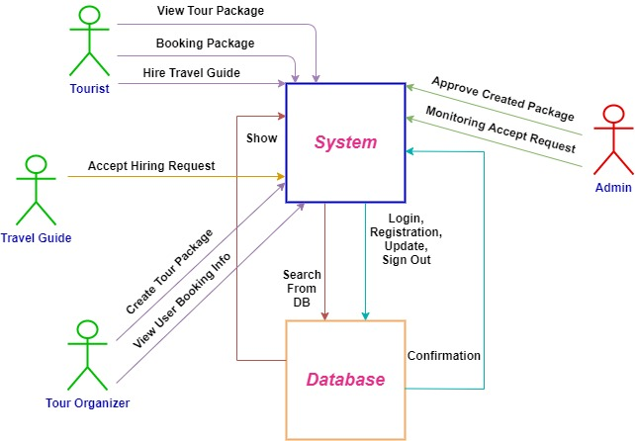

**Figure 1.1: Propose System Model**

In this system user should register for using the system. To registration a user, first he/she give his/her information. After register, a user can use the system through login using email, NID and password. Than the user can hire travel guide as needed. According to the user choice, he can select tour package and booking package. After confirmation by the user, system booked the package for that user.

## 1.7 Project Plan

Properly full fill the requirements and complete the project at the right time, project schedule helps for proper planning. I also make a project schedule to complete my project properly.

**Table 1.1: Project Plan**

|  |  |  |  |  |
| --- | --- | --- | --- | --- |
| **Task Name** | **Resource Name** | **Start** | **Finish** | **Duration(Days)** |
| **Planning** | PM,BA, | 01-06-2019 | 12-06-2019 | 12 |
| **Requirement** | RE, RA | 13-06-2019 | 18-07-2019 | 36 |
| **System Design** | UI Designer, | 19-07-2019 | 16-09-2019 | 60 |
| **Database Design** | DB Designer | 17-09-2019 | 16-10-2019 | 30 |
| **Development** | Developer | 17-10-2019 | 29-02-2020 | 136 |
| **Testing** | Tester | 01-03-2020 | 25-03-2020 | 25 |
| **Implementation** | Implementation Eng. | 25-03-2020 | 12-04-2020 | 18 |
| **Delivery** | PM, Implementation Eng. | 13-04-2020 | 25-04-2020 | 13 |
|  |  |  | **Total** | 330 Days |

## 1.8 Gantt chart

In project planning, I use Gantt chart to manage my project properly. To use these tools, I can track the entire task which is not done or not. Also track which one is schedule for the next task. I control my project duration by these tools.

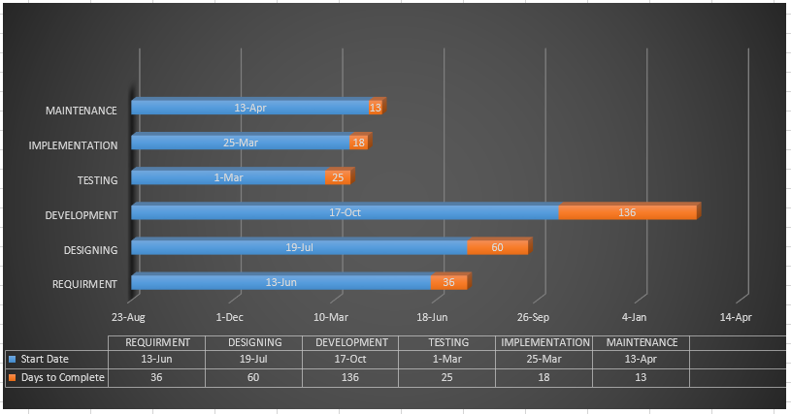

**Figure 1.2: Gantt chart**

## 1.9 Risk

In Gantt chart tools, I show the project duration. I took days for developing, so that I could mitigate my risk. In developing page, I find out a risk that risk is developer. Who may sick or leave.

## 1.10 Milestone

Milestones, a time frame of a project, will define the task. These project milestones are as follows:

**Table 1.2: Project Milestone**

|  |  |  |
| --- | --- | --- |
| **Task No** | **Task Name** | **Duration** |
|  |  |  |
| **01** | **Planning** | **12 Days** |
|  |  |  |
| **02** | **Requirement gathering & Analysis** | **36 Days** |
|  |  |  |
| **03** | **System Design** | **60 Days** |
|  |  |  |
| **04** | **Data Base Design** | **30 Days** |
|  |  |  |
| **05** | **Development** | **136 Days** |
|  |  |  |
| **06** | **Testing** | **25 Days** |
|  |  |  |
| **07** | **Implementation** | **18 Days** |
|  |  |  |
| **08** | **Relies** | **13 Days** |
|  |  |  |
|  | **Total** | **330 Days** |
|  |  |  |

**Chapter Two**

# Software Requirement Specification

## 2.1 Requirement satisfaction

Requirement is the process of identifying the user satisfaction form the System. So, Requirement is an important part of project management.

When I selected this project I thought about some specific Software requirement, like as

* Who is the stakeholder of this system?
* Is it helpful for them or not?
* Functional & Non- functional requirements?
* Is it efficient for using?

## 2.2 Functional requirement

The functional requirements of the system are like below –

### 2.2.1 User Registration

**Table 2.1: User Registration**

|  |  |
| --- | --- |
| **FR-01** | **User Registration** |
| **Description** | In this system there are many users like Tourist, Travel guide, Tour Event Organization, Admin, visitor etc. But registration is must for those User who want to hire Travel guide, get tour package and create tour event. This page is required some information like as username, email, phone number, NID number, user type etc. and store the information. |
| **Stakeholder** | **Traveler, Travel Guide, Tour Organizer, Admin** |

### 2.2.2 User Login

**Table 2.2: Discuss About User Login**

|  |  |
| --- | --- |
| **FR-02** | **User Login** |
| **Description** | Here, login is must for those User who want to hire Travel guide, get tour package and create tour event. This page is required some information like as email, NID number, and password to login in this system after registration. |
| **Stakeholder** | **Traveler, Travel Guide, Tour Organizer, Admin** |

### 2.2.3 Hire Travel Guide

**Table 2.3: Discuss About Hire Travel Guide**

|  |  |
| --- | --- |
| **FR-03** | **Hire Travel Guide** |
| **Description** | Only registered user can hire travel guide as his tour helper. This module will help the user to hire travel guide through taking some information. |
| **Stakeholder** | **Traveler** |

### 2.2.4 Accept Hiring Request

**Table 2.4: Discuss About Accept Request**

|  |  |
| --- | --- |
| **FR-04** | **Accept Hiring Request** |
| **Description** | Only registered Travel Guide can accept request which is send from traveler. This module will help the Travel Guide to accept hiring request and sent confirmation to traveler. |
| **Stakeholder** | **Travel Guide** |

### 2.2.5 Create Tour Event

**Table 2.5: Discuss About Create Tour Event**

|  |  |
| --- | --- |
| **FR-05** | **Create Tour Event** |
| **Description** | Only registered Tour Organizer can create tour event for getting tourist. This module will help the user to create tour events through taking some information by the system. |
| **Stakeholder** | **Tour Organizer or Company** |

### 2.2.6 Approve Tour Event

**Table 2.6: Discuss About Approve Event**

|  |  |
| --- | --- |
| **FR-06** | **Approve Tour Event** |
| **Description** | Only Admin can approve created tour event for showing on traveler wall. This module will help the user to approve created tour events. |
| **Stakeholder** | **Admin** |

### 2.2.7 Show and Booking Tour Package

**Table 2.7: Discuss About Booking Tour Package**

|  |  |
| --- | --- |
| **FR-07** | **Show and Booking Tour Package** |
| **Description** | Only registered Traveler can show tour packages which are approved by Admin and booking those from his wall. This module will help the traveler to show and booking package. |
| **Stakeholder** | **Traveler** |

### 2.2.8 Monitoring System

**Table 2.8: Discuss About Monitoring System**

|  |  |
| --- | --- |
| **FR-08** | **Monitoring System** |
| **Description** | Without Admin there is nobody monitor the whole system. Only Admin can track all users’ information. |
| **Stakeholder** | **Admin** |

## 2.3 Performance Requirement

It’s very necessary to sustain the performance of the project. To assure the better performance, this project has to meet some requirements which will provide the better performance.

### 2.3.1 Speed and Latency Requirement

While inserting or viewing the system in the browser, system need a minimum amount of speed to perform the task.

**Table 2.9: Discuss About Speed and Latency Requirement**

|  |  |
| --- | --- |
| **SLR-01** | **The system will be faster** |
| **Description** | When the user browsing, it depends on their internet speed. It also depends on server bandwidth speed. |
| **Stakeholders** | **User, Admin, Visitor** |

### 2.3.2 Legibility and accuracy requirements

System has to confirm the Legibility and Accuracy of the data.

**Table 2.10: Discuss About Legibility and Accuracy**

|  |  |
| --- | --- |
| **LAR-01** | **Data accuracy** |
| **Description** | The input data should be correct and right pattern data, otherwise the input information never save. Like email, username, NID, user type etc. the input information is not valid, the data never save. Or the input data pattern is not match; the system never saves or accepts the data. |
| **Stakeholders** | **User, Admin, Visitor** |

### 2.3.3 Capacity requirements

The system should maintain the all inserting data.

**Table 2.11: Explain on Capacity Requirements**

|  |  |
| --- | --- |
| **CR-01** | **Manage the all data in database system.** |
| **Description** | All registration data like Traveler, Travel Guide, Tour Organizer, Admin data and other information are store in the database in right format. |
| **Stakeholders** | **User, Admin, Visitor.** |

### 2.3.4 Dependability requirements

Dependability means, it measures of a system availability, reliability, security etc. Here, dependability means the run time of this project.

### 2.3.5 Reliability and availability

**Table 2.12: Explain on Reliability and Availability**

|  |  |
| --- | --- |
| **RA-01** | The system must be available 24x7 |
| **Description** | * It’s available 24 hours in a day * The system must be updated regularly |
| **Stakeholders** | **Traveler, Travel Guide, Tour Organizer, Admin, Visitor.** |

### 2.3.6 Safety critical requirements:

There are no specific safety critical requirements.

## 2.4 Maintainability and supportability

To maintain the system and support the system, some people are connected with the project.

### 2.4.1 Supportability requirements specification

* + **SRS-1.** Understand the system's behavior on a technical support is required by the system operator. The reason for reading them might be
  + **SRS-2.** System malfunction has occurred and the system operator has to find the exact point of time when this happened
  + **SRS-3.** System produces wrong results and the developers must be able to reproduce the data flow through the system
  + **SRS-4**. Anyone tried to breach the system's security mechanisms and the system operator must understand what he did.

## 2.5 Adaptability requirements

There is no specific adaptability Requirements.

### 2.5.1 Security requirements

* **SR-1.** Log in as a Traveler
* **SR-2.** Log in as Travel Guide.
* **SR-3.** Log in as a Tour Organization.
* **SR-4.** Log in as an Admin.

To get access to this system or a specific module the system must provide an authentication mechanism. To prevent anyone to exploit stolen Data all user’s password must be encrypted in hash process.

### 2.5.2 Access requirements

This system provides accesses the different module, by access the authentication way the authentic user.

### 2.5.3 Integrity requirements

To prevent credentials information of user from being stolen, all passwords are stored in encrypted form. The Requirements significantly reduces the value of stolen user credentials, it’s not easy to decrypt the password.

## 2.6 Usability and human integrity requirements

This system easy to use and all the person who wants to get a travel guide or tour package and who manage it.

## 2.7 Data Validation

In this stage I have try to validate almost all input field.

## 2.8 User Interface Design

It is important to consult the system users and their necessities while designing the user interface.

**Chapter Three**

# Software Requirement Analysis

## 3.1 Use Case Diagram:

In this system a user what things he/she can do, is describe in this picture that provide in below. A user can login in the system. But before login he/she must registration in this system as a user which has three types like Traveler, Travel Guide and Tour Organizer. Then they can access the login option. After login Traveler can access on his/her portal to take travel guide or booking tour package for his/her easy travel. Tour Guide can access on his own portal to response traveler request. Tour Organizer can create tour event or package to get tourist for his/her business. Admin should login to approve created tour package and he/she can manage all the event, task of the system.

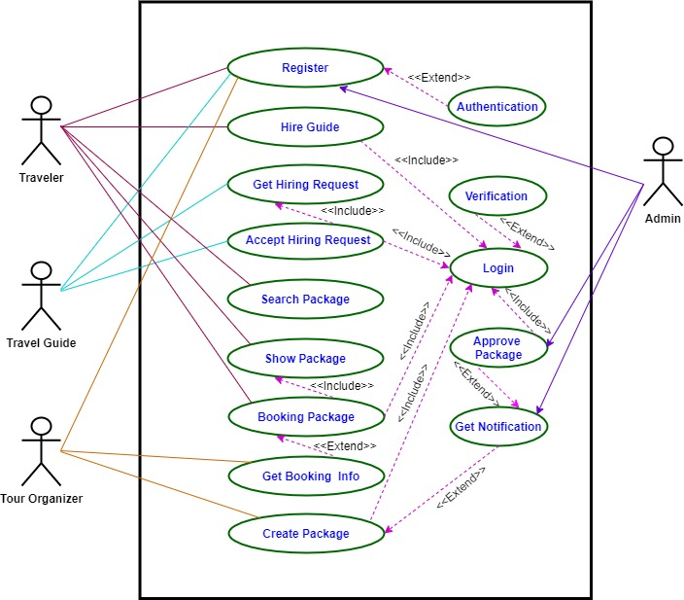

**Figure 3.1: Use Case Diagram**

### 3.1.1 Registration

**Table 3.1: Use Case Description of Registration**

|  |  |  |
| --- | --- | --- |
| Use Case | Registration | |
| Use case no | 01 | |
| Goal | Register to the system | |
| Precondition | Need to fill up with correct information | |
| Primary actor  Secondary actor | Traveler, Travel Guide, Tour Organizer, Admin  None | |
| Trigger | Button | |
| Description/Main success scenario | Step | Action |
|  | Browse into the system |
|  | Select the registration button if new in this system |
|  | Select submit button |
|  | Registration complete |
| Post Condition | User can login with email, NID & password | |
| Alternative flow | Not applicable | |

### 3.1.2 Login

**Table 3.2 : Use Case Description of Login**

|  |  |  |
| --- | --- | --- |
| Use case | Login | |
| Use case no | 02 | |
| Goal | Login into the system to change anything into the system | |
| Precondition | Must be registered | |
| Primary actor  Secondary actor | Traveler, Travel Guide, Tour Organizer, Admin  None | |
| Trigger | Button | |
| Description/Main success scenario | Step | Action |
|  | Visit the Travel Guide system home page |
|  | Select login page |
|  | Submit email, NID and password |
|  | If yes, than login successful |
| Post Condition | System response with a login successful message | |
| Alternative flow | Not applicable | |

### 3.1.3 Hire Guide

**Table 3.3 : Use Case Description of Hire Guide**

|  |  |  |
| --- | --- | --- |
| Use case | Hire Guide | |
| Use case no | 03 | |
| Goal | To take a Travel Guide as a tour assistant from this system | |
| Precondition | Must be Login into the system | |
| Primary actor  Secondary actor | Traveler  None | |
| Trigger | Button | |
| Description/Main success scenario | Step | Action |
| 1. | Login into the system |
| 2. | Go to Hire guide page |
| 3. | Provide required information about tour plan |
| 4. | Click Hire Guide button to send request |
| Post Condition | System response with a successful message | |
| Alternative flow | Not applicable | |

### 3.1.4 Get Hiring Request

**Table 3.4 : Use Case Description of Get Hiring Request**

|  |  |  |
| --- | --- | --- |
| Use case | Get Hiring Request | |
| Use case no | 04 | |
| Goal | Get hiring request from traveler | |
| Precondition | Must be Login into the system | |
| Primary actor  Secondary actor | Travel Guide  None | |
| Trigger | Button | |
| Description/Main success scenario | Step | Action |
| 1. | Login into the system |
| 2. | Check notification option from profile page |
| Post Condition | Show request details | |
| Alternative flow | Not applicable | |

### 3.1.5 Accept Hiring Request

**Table 3.5: Use Case Description of Accept Hiring Request**

|  |  |  |
| --- | --- | --- |
| Use case | Accept Hiring Request | |
| Use case no | 05 | |
| Goal | Accept hiring request to perform as a travel guide | |
| Precondition | Must be Login into the system and get request | |
| Primary actor  Secondary actor | Travel Guide  None | |
| Trigger | Button | |
| Description/Main success scenario | Step | Action |
| 1. | Login into the system |
| 2. | View notification from profile page |
| 3. | Check that it is available or not |
| 4. | Click on Accept request button if it is available |
| Post Condition | System response with a successful message | |
| Alternative flow | Not applicable | |

### 3.1.6 Search package

**Table 3.6: Use Case Description of Search Package**

|  |  |  |
| --- | --- | --- |
| Use case | Search package | |
| Use case no | 06 | |
| Goal | Search preferable package with tourist place name | |
| Precondition | Must be Login into the system and go to search box | |
| Primary actor  Secondary actor | Traveler  None | |
| Trigger | Button | |
| Description/Main success scenario | Step | Action |
| 1. | Login into the system |
| 2. | Go to search box from profile page |
| 3. | Write tourist place name |
| 4. | Press enter or click for searching |
| Post Condition | System response with available package | |
| Alternative flow | Not applicable | |

### 3.1.7 Show package

**Table 3.7: Use Case Description of Show package**

|  |  |  |
| --- | --- | --- |
| Use case | Show package | |
| Use case no | 07 | |
| Goal | Show all category of tour packages | |
| Precondition | Must be Login into the system | |
| Primary actor  Secondary actor | Traveler  None | |
| Trigger | Button | |
| Description/Main success scenario | Step | Action |
| 1. | Login into the system |
| 2. | Go to Tour Package page from profile page |
| 3. | View all post of tour packages |
| Post Condition | System show available package | |
| Alternative flow | Not applicable | |

### 3.1.8 Booking package

**Table 3.8: Use Case Description of Booking Package**

|  |  |  |
| --- | --- | --- |
| Use case | Booking package | |
| Use case no | 08 | |
| Goal | Booking specific tour package from all package | |
| Precondition | Must be Login into the system | |
| Primary actor  Secondary actor | Traveler  None | |
| Trigger | Button | |
| Description/Main success scenario | Step | Action |
| 1. | Login into the system |
| 2. | Go to Tour Package page from profile page |
| 3. | View all post of tour packages |
| 4. | Click on Booking button which is choice |
| Post Condition | System response with a successful message | |
| Alternative flow | Not applicable | |

### 3.1.9 Get Booking Information

**Table 3.9: Use Case Description of Get Booking Information**

|  |  |  |
| --- | --- | --- |
| Use case | Get Booking Information | |
| Use case no | 09 | |
| Goal | Get booking information which are booked | |
| Precondition | Must be Login into the system | |
| Primary actor  Secondary actor | Tour Organizer  None | |
| Trigger | Button | |
| Description/Main success scenario | Step | Action |
| 1. | Login into the system |
| 2. | Go to notification option |
| 3. | View booking information who is booked which package |
| Post Condition | System show booking information | |
| Alternative flow | Not applicable | |

### 3.1.10 Create package

**Table 3.10: Use Case Description of Create Package**

|  |  |  |
| --- | --- | --- |
| Use case | Create package | |
| Use case no | 10 | |
| Goal | To create tour package or event | |
| Precondition | Must be Login into the system | |
| Primary actor  Secondary actor | Tour organizer  None | |
| Trigger | Button | |
| Description/Main success scenario | Step | Action |
| 1. | Login into the system |
| 2. | Go to Create event page from profile page |
| 3. | Fill up all required option to create an event or package |
| 4. | Click on Create button |
| Post Condition | System response with a successful message | |
| Alternative flow | Not applicable | |

### 3.1.11 Approve package

**Table 3.11: Use Case Description of Approve Package**

|  |  |  |
| --- | --- | --- |
| Use case | Approve package | |
| Use case no | 11 | |
| Goal | To approve tour package or event which are created | |
| Precondition | Must be Login into the system | |
| Primary actor  Secondary actor | Admin  None | |
| Trigger | Button | |
| Description/Main success scenario | Step | Action |
| 1. | Login into the system |
| 2. | Go to notification option from profile page |
| 3. | View created package which is unapproved |
| 4. | Click on Approve button to show new created package on Tour Package page of Traveler’s profile. |
| Post Condition | System response with showing approved which was unapproved | |
| Alternative flow | Not applicable | |

## 3.2 Activity Diagram

Following activity diagrams are exactly describing the flow of the different state of the project.

### 3.2.1 Registration

By this figure I explain my system. If anyone enter the system, he/she see the all the option. And who are registered user and he/she can login in the system. According to the rule he/she can access different potion.

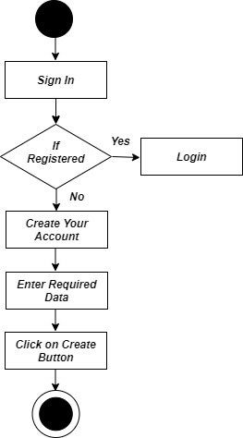

**Figure 3.2: Activity Diagram of Registration**

### 3.2.2 Login

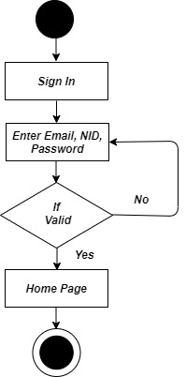

**Figure 3.3: Activity Diagram of Login**

### 3.2.3 Hire Travel Guide

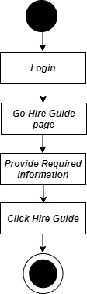

**Figure 3.4: Activity Diagram of Hire Travel Guide**

### 

### 3.2.4 Get and Accept Hiring Request

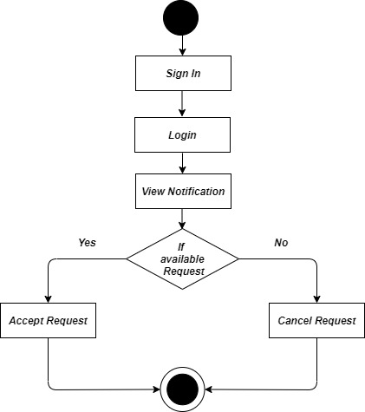

**Figure 3.5: Activity Diagram of Accept Hiring Request**

### 3.2.5 Search and Show Package

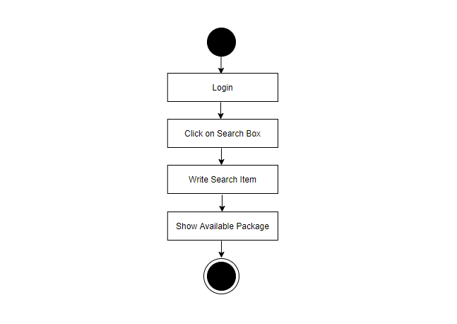

**Figure 3.6: Activity Diagram of Search and Show Package**

### 3.2.6 Booking Package

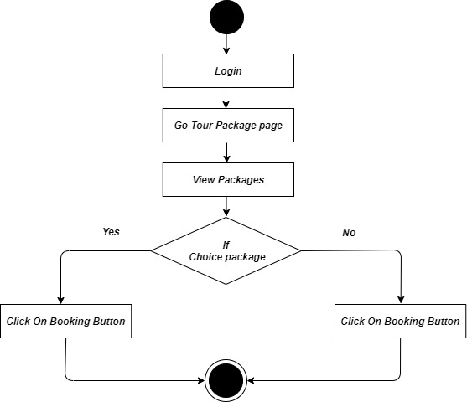

**Figure 3.7: Activity Diagram of Booking Package**

### 3.2.7 Get Booking Information

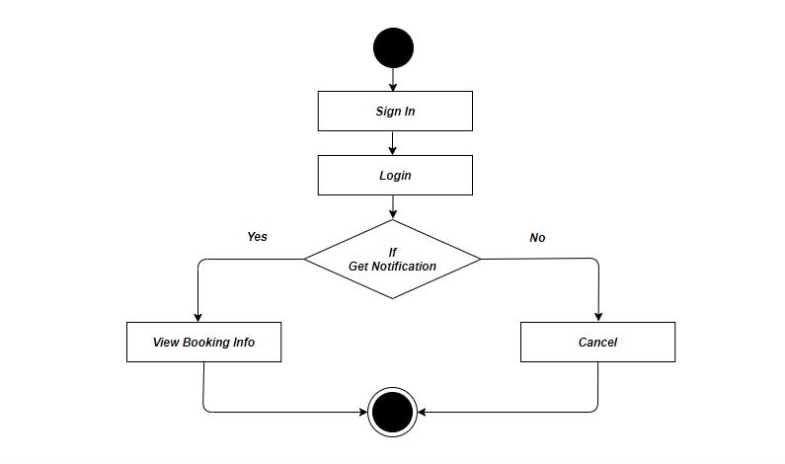

**Figure 3.8: Activity Diagram of get Booking Information**

### 3.2.8 Create Package

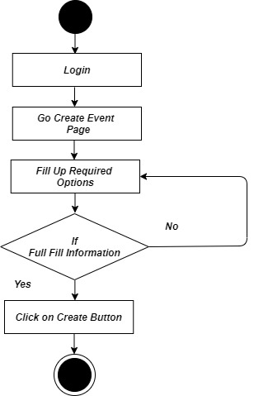

**Figure 3.9: Activity Diagram of Create package**

### 3.2.9 Approve Created Package

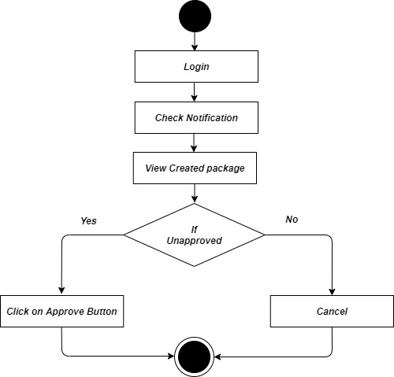

**Figure 3.10: Activity Diagram of Approve Package**

## 3.3 Sequence Diagram:

Sequence Diagram show the process in sequential way that it’s actor done. In this section describe the sequence system to database.

### 3.3.1 Registration:

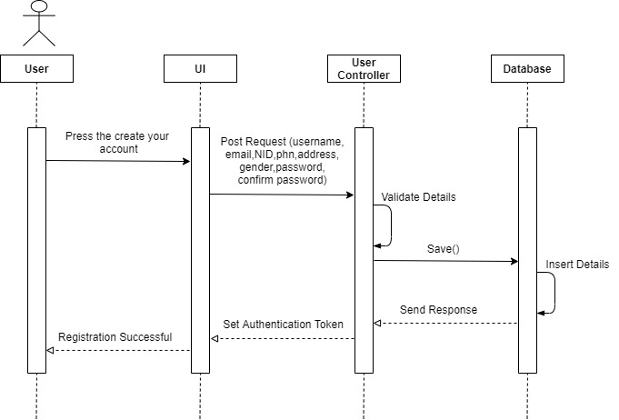

**Figure 3.3.1: Registration of Sequence Diagram**

### 3.3.2 Login:

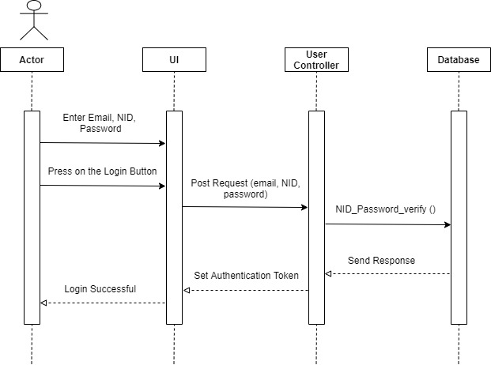

**Figure 3.3.2: Login of Sequence Diagram**

### 3.3.3 Hire Travel Guide:

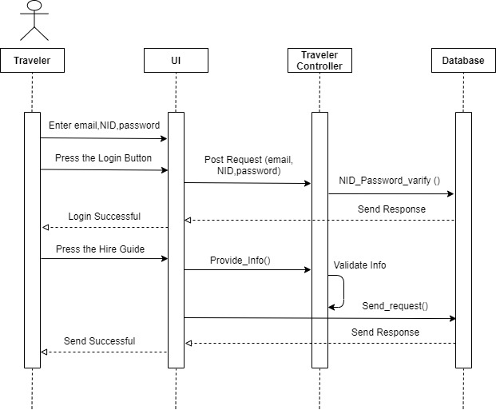

**Figure 3.3.3: Sequence Diagram of Hire Travel-Guide**

### 3.3.4 Booking Package:

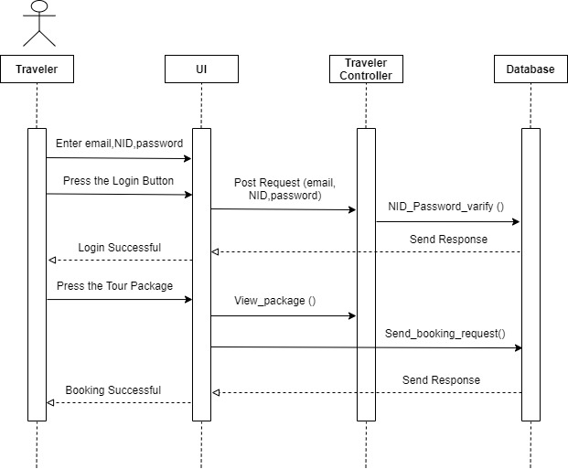

**Figure 3.3.4: Sequence Diagram of Booking Package**

### 3.3.5 Get and Accept Hiring Request:

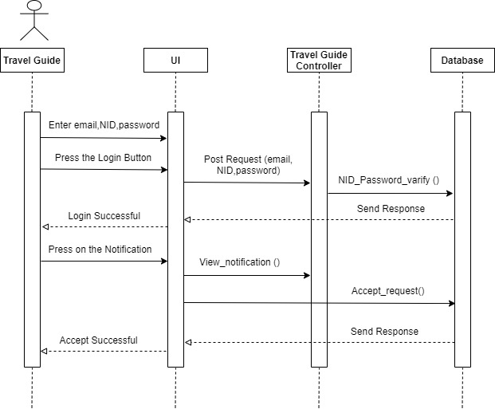

**Figure 3.3.5: Get and Accept Hiring Request**

### 3.3.6 Get Booking Information:

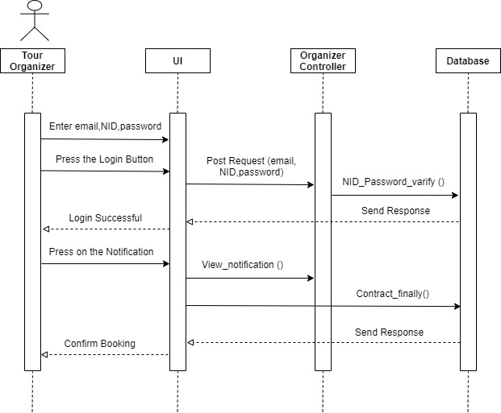

**Figure 3.3.6: Get Booking Information of Sequence Diagram**

### 3.3.7 Create Tour Package:

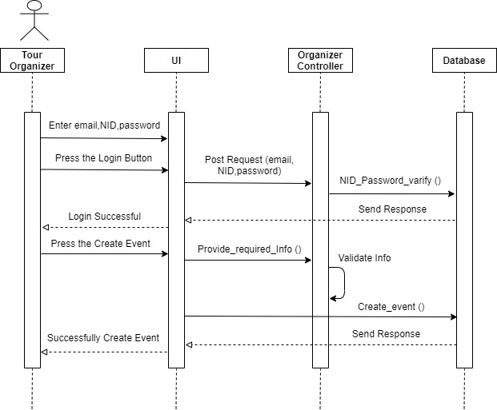

**Figure 3.3.7: Create Tour Package of Sequence Diagram**

### 3.3.8 Approve Created Package:

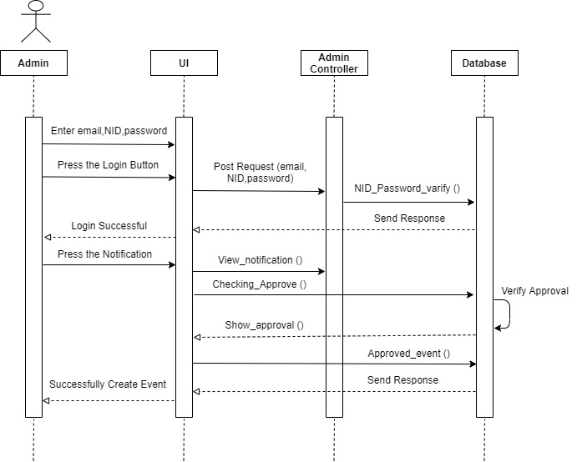

**Figure 3.3.8: Sequence Diagram of Approve Created Package**

### 3.3.9 Monitor User Information:

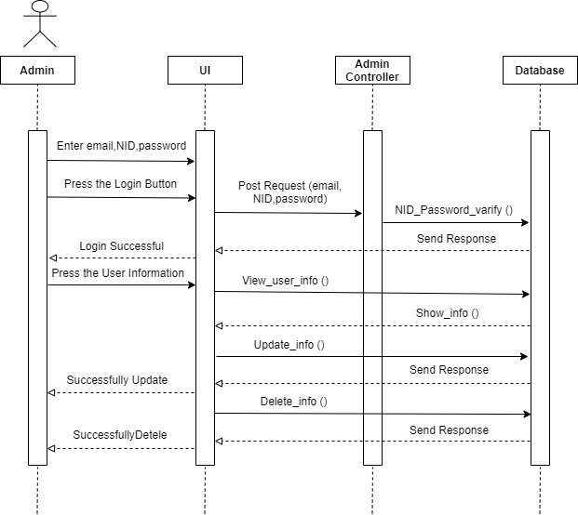

**Figure 3.3.9: Sequence Diagram of Monitor User Information**

## 3.4 Class Diagram:

To Describe the system properly and its process with attributes and methods.

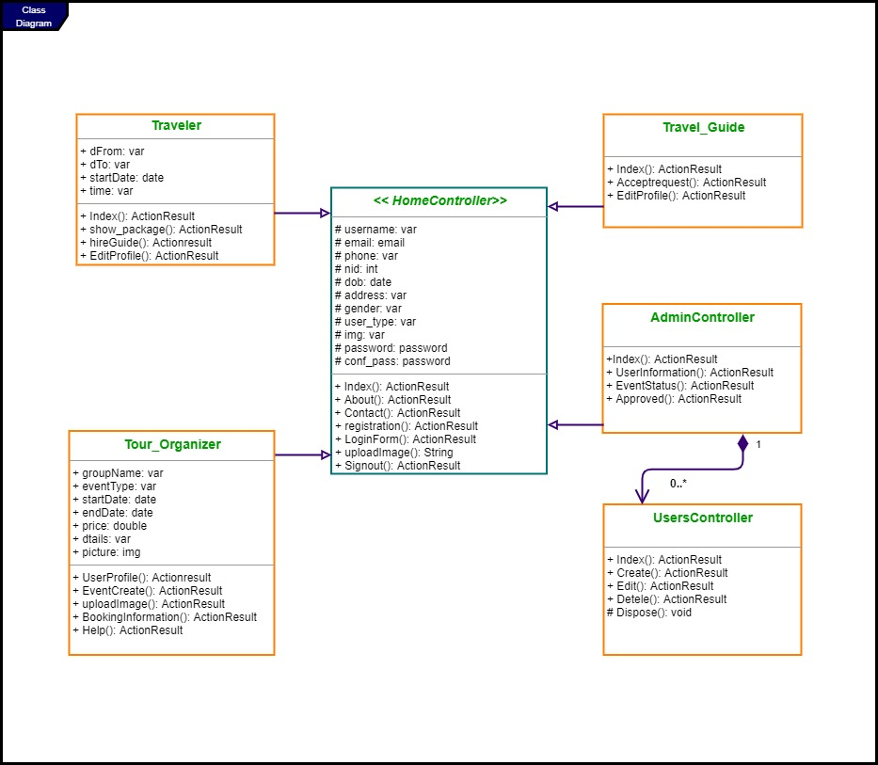

**Figure 3.4.1 : Class Diagram**

## 3.5 Entity Relationship Diagram:

To describe the system database with its table, primary key, foreign key and the relation between the tables.

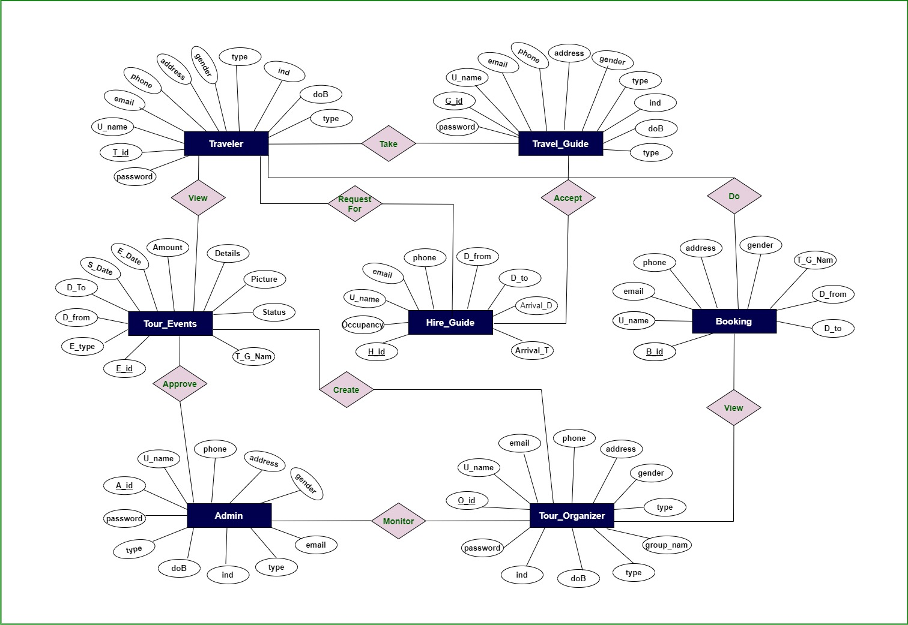

**Figure 3.5.1: Entity Relationship Diagram**

**Chapter Four**

# Technology and Tools

## 4.1 User Interface Technology

User interface (UI) is everything designed into a system view that a person’s associates with this system may like the interface of this system.

### 4.1.1 Technology

* Programming language: C#
* Web server: IIS Express
* Design: html, CSS, bootstrap, JavaScript, JQuery
* Framework: ASP.NET MVC

### 4.1.2 Tools

* Microsoft Visual Studio
* Sublime Text 3

## 4.2 Database Technology

Database technology take information and store, organize, and process it in a way that enables users to easily and intuitively go back and find details they are searching for.

### 4.2.1 Technology

* Database server: SQL Server Management Studio

### 4.2.2 Tool

* SQL Server Management Studio

**Chapter Five**

# Implementation

## 5.1 Hardware & Software Specifications

In this stage I want to describe what’s needed to build this application.

### 5.1.1 Hardware Requirements

* + PROCESSOR: Dual Core or above
  + RAM: 2GB or above
  + Cache Memory: 2MB or above
  + HDD: 20GB or above

### 5.1.2 Software Requirements

* **IDE**: Visual Studio
* **Database:** SQL Server Management Studio
* **Web-Server:** IIS express

**Chapter Six**

# User Manual

## 6.1 Home Page

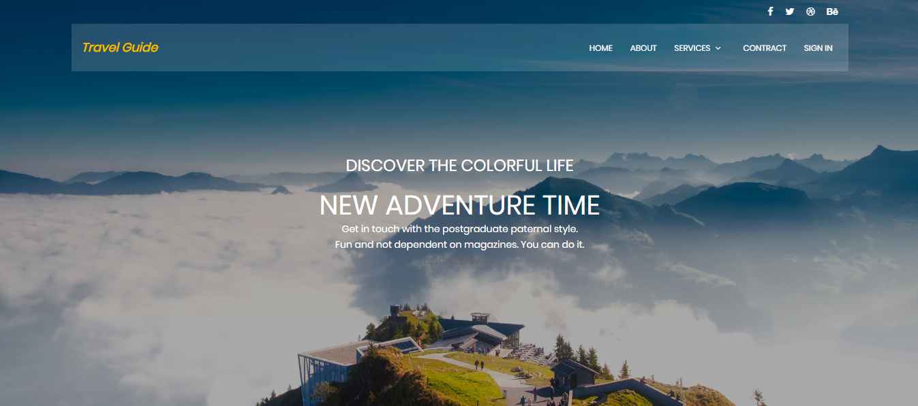

**Figure 6.1: UI Design of Home Page**

## 6.2 Registration

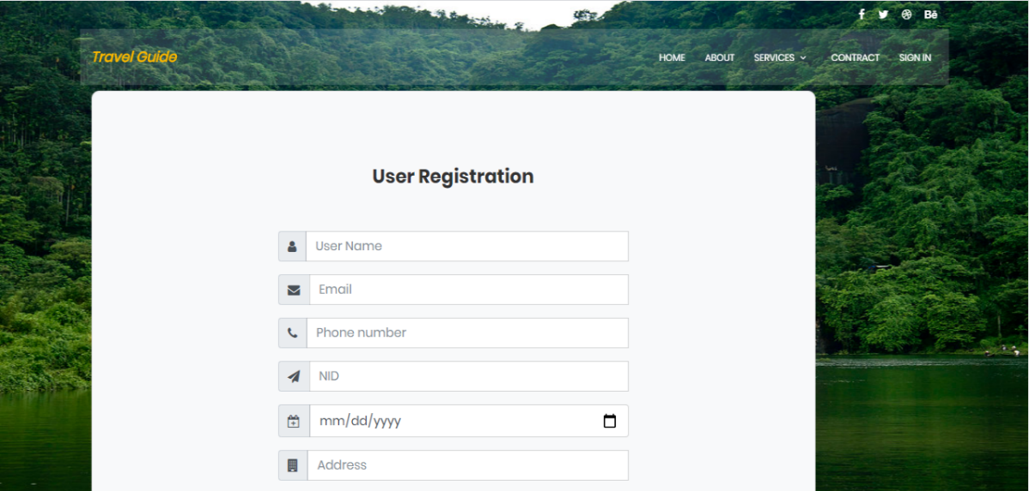

**Figure 6.2: UI Design of Registration Page**

## 6.3 Login

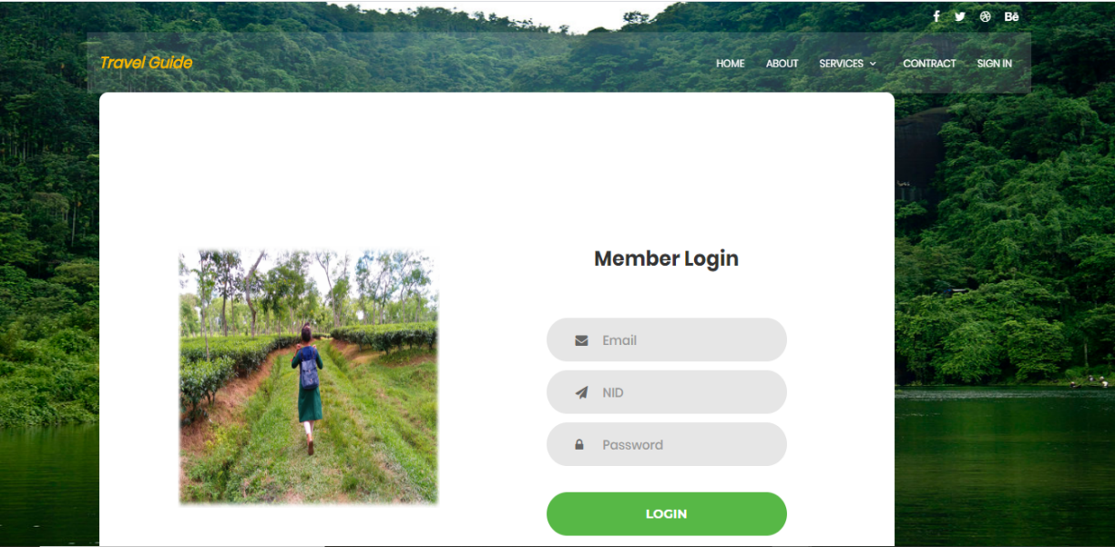

**Figure 6.3: UI Design of Login Page**

## 6.4 About

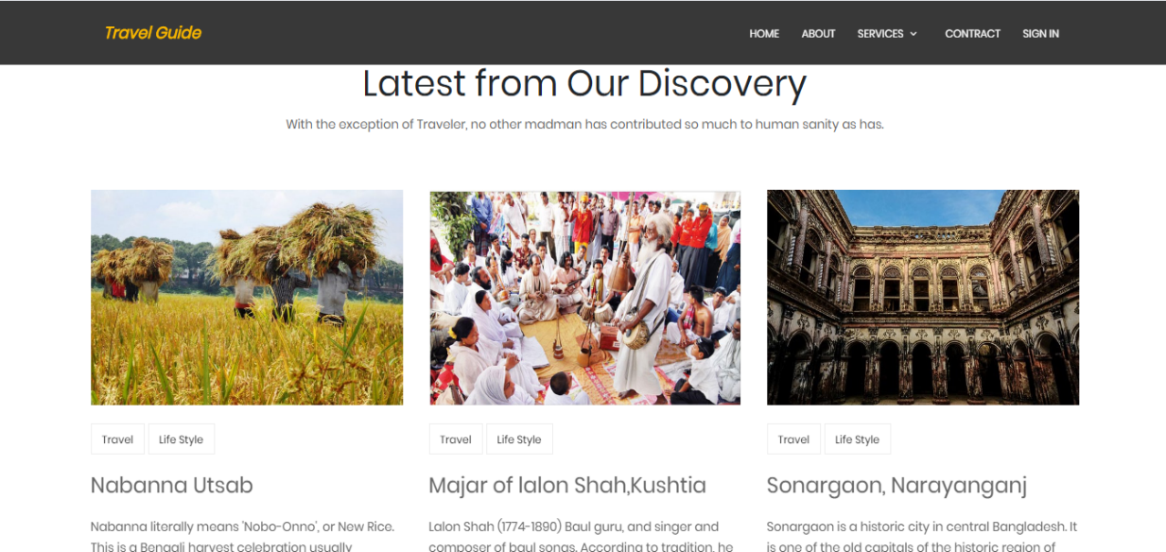

**Figure 6.4: UI / UX Design of About Page**

## 6.5 Contract

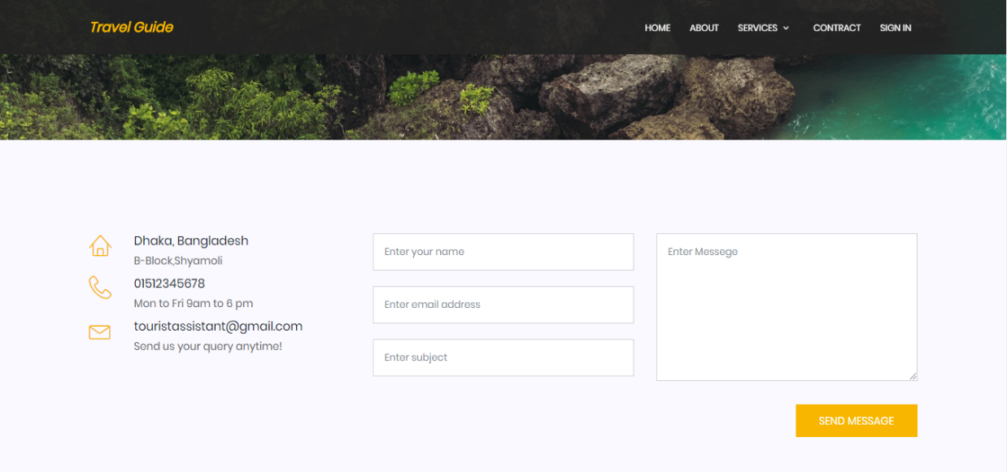

**Figure 6.5: UI / UX Design of Contract Page**

## 6.6 Hire Guide

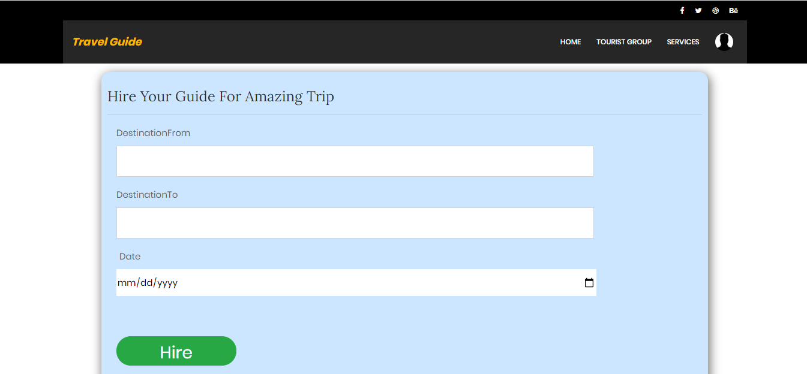

**Figure 6.6: UI / UX Design of Hire Guide Page**

## 6.7 Accept Hire Request

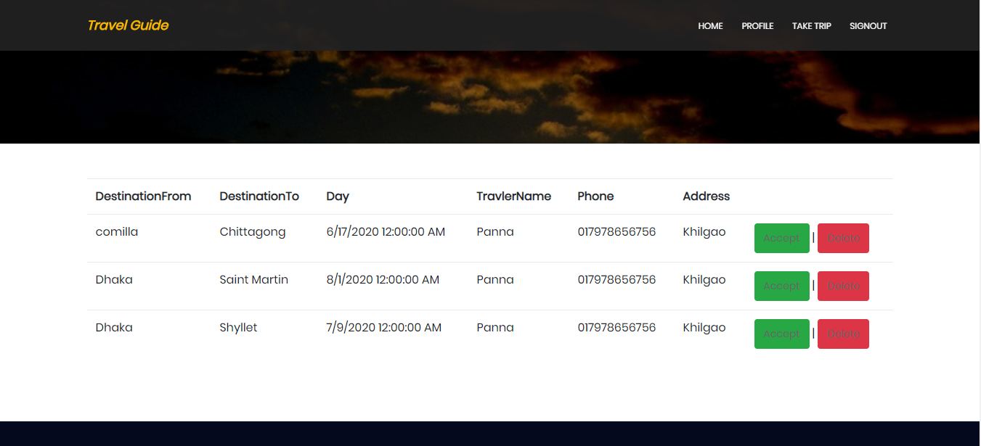

**Figure 6.7: UI / UX Design of Accept Hire Request Page**

## 6.8 Create Tour Event

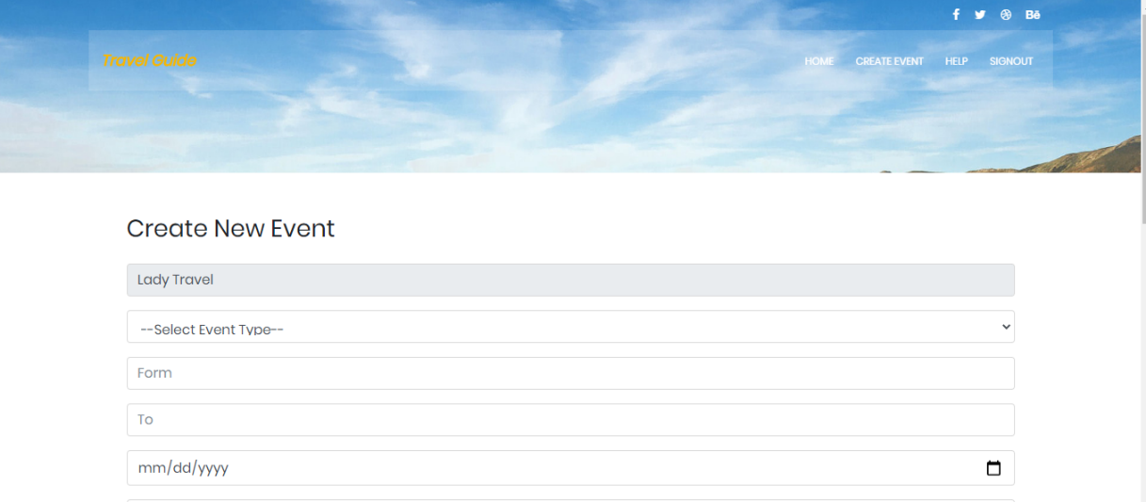

**Figure 6.8: UI / UX Design of Create Tour Event Page**

## 6.9 Approve Created Event

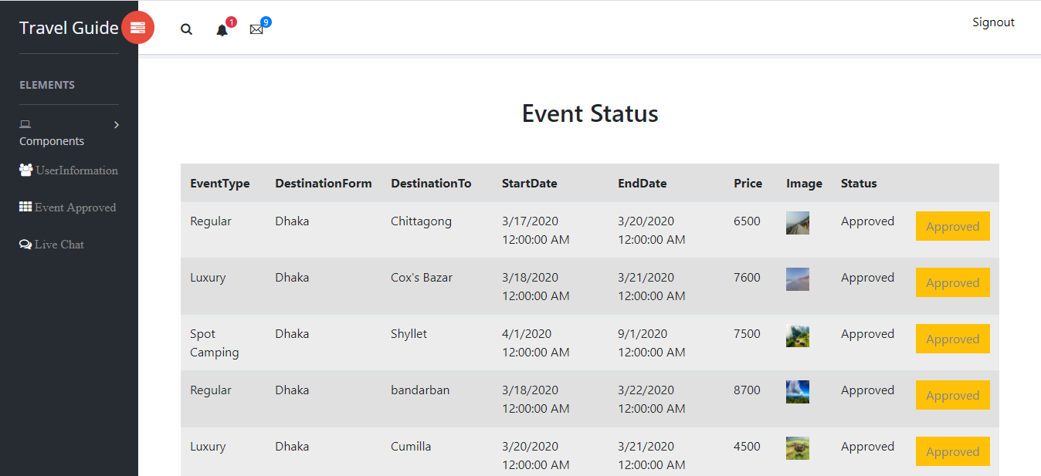

**Figure 6.9: UI / UX Design of Approved Event Page**

## 6.10 Show and Booking Package

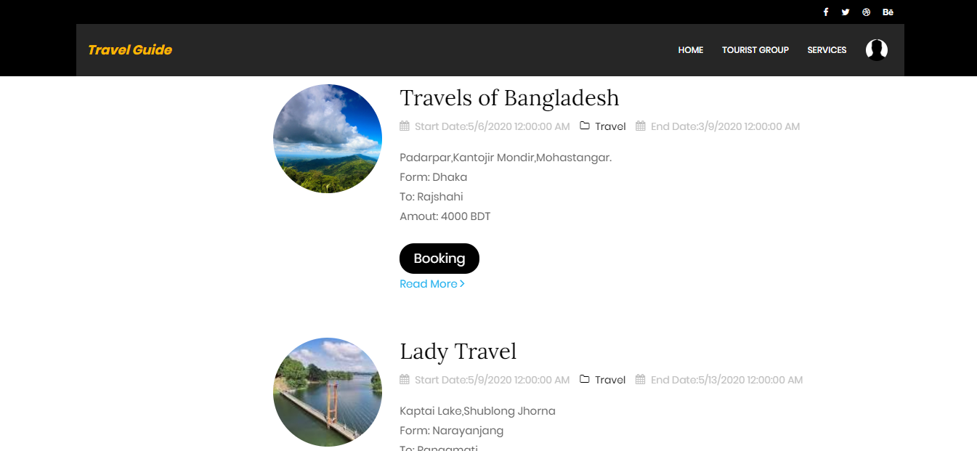

**Figure 6.10: UI / UX Design of Show and Booking Page**

## 6.11 User Booing Information

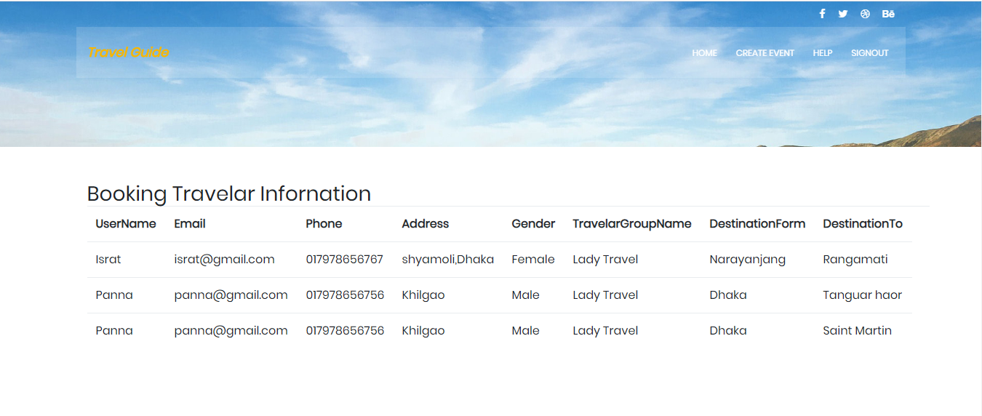

**Figure 6.11: UI / UX Design of User Booking Information Page**

## 6.12 Help

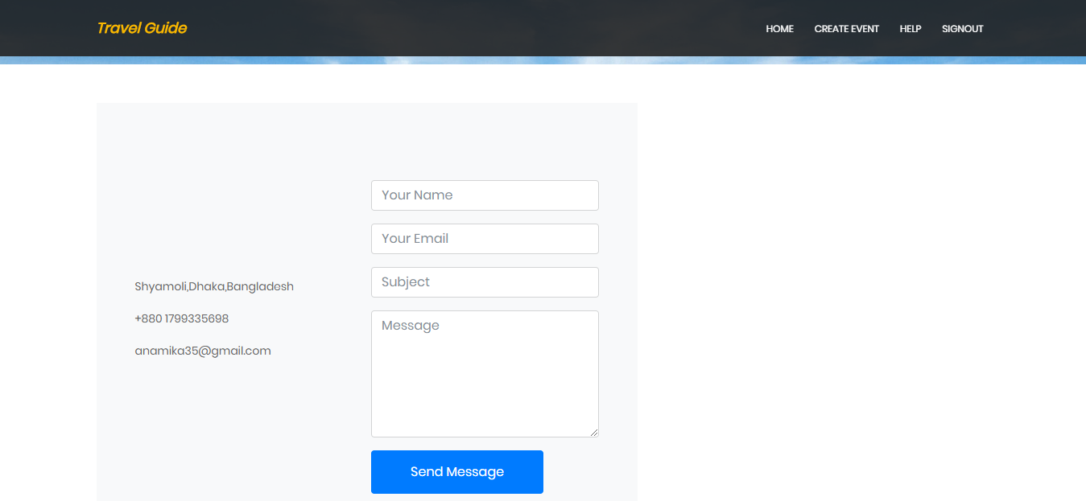

**Figure 6.12: UI / UX Design of Help Page**

## 6.13 User Information

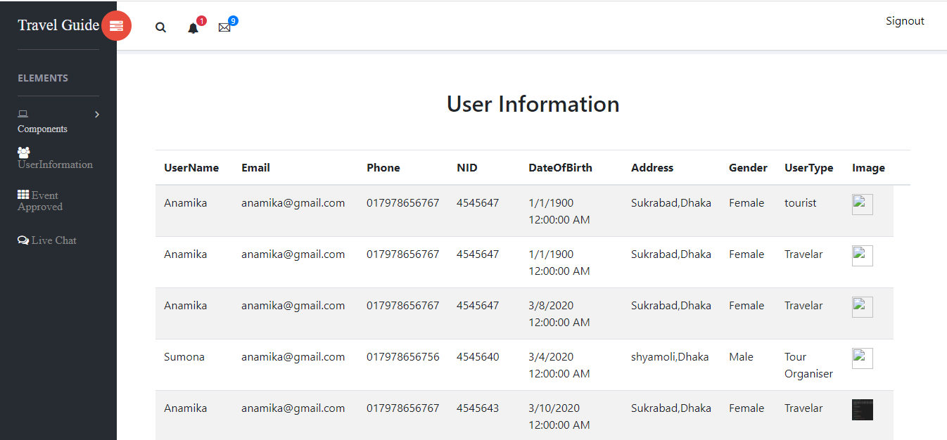

**Figure 6.13: UI / UX Design of User Information Page**

**Chapter Seven**

# System Testing

## 7.1 Testing

The testing of the software was done in full manual end user data flow testing style. The testing approach is narrated here omitting the technical details.

Two common type of testing is black box testing and white box testing. Black box testing is also called functional testing. In this stage we test only functionality, input, and output. White box testing is structure level testing. For this project I have used black box testing method.

## 7.2 Testing Strategy

A testing strategy is a general approach to the testing process rather than a method of devising particular system or component tests. Different testing strategies may be adopted depending on the type of system to be tested and the development process used.

**In this project I have used Black Box Testing method**.

## 7.3 Test approach

A test approach is the test strategy implementation of a project, defines how testing would be carried out. Test approach has two techniques:

* **Proactive -** An approach in which the test design process is initiated as early as possible in order to find and fix the defects before the build is created.
* **Reactive -** An approach in which the testing is not started until after design and coding are completed.

### 7.3.1 Black Box Testing

Black box trying out additionally referred to as purposeful checking out that ignores the inner mechanism of a device or element and specializes in the outputs generated in response to selected inputs and execution conditions. We've decided to perform equivalence partitioning and Boundary value evaluation for this gadget.

### 7.3.2 White Box Testing

White box checking out is a software trying out method wherein the inner structure or implementation of the item being examined is understood to the tester. The tester chooses inputs to workout paths thru the code and determines the proper outputs. Programming understand how and the implementation know-how is crucial.

## 7.4 Pass / Fail Criteria

The entrance criteria for each phase of testing must be met before the next phase can commence. Now the criteria for pass and fail are given below.

* According to the given scenario the expected result need to take place then the scenario will be considered as pass otherwise that criteria should be failed.
* If an item tested 10 times, 9 times perfectly worked and single time do not work properly then it will consider as fail case.
* System crash will be considered as fail case.
* After submitting a query in the system, if expected page won’t appear then it will be considered as fail case.

## 

## 7.5 Testing Environment

Testing environment is a setup of software and hardware for the testing teams to execute test cases. In other words, it supports test execution with hardware, software and network configured.

For test environment, key area to set up includes.

* System and applications
* Test data
* Database server
* Front end running environment
* Client operating system
* Browser, Network
* Hardware includes Server Operating system
* Documentation require like reference documents/configuration guides/installation guides/ user manuals.

## 7.6 Use Case Testing

Use Case Testing is a functional Black Box Testing technique that helps to identify test scenarios that exercise the whole system on each transaction basis from start to finish.

## 7.7 Test Case

A test case is a document, which has a set of test data, preconditions, expected results and post conditions, developed for a particular test scenario in order to verify compliance against a specific requirement

### 7.7.1 Test case for User Registration

**Table 7.7.1: Test case for User Registration (Pass)**

|  |  |  |  |  |  |  |  |
| --- | --- | --- | --- | --- | --- | --- | --- |
| **Test Case ID: TC 01** | | | | **Module Name: Registration** | | | |
| **Sub Module: User Registration** | | | | **Test Designed by:** Anamika | | | |
| **Test Priority (Low/Medium/High):** High | | | | **Test Designed date:** 20/04/20 | | | |
| **Test Title: Student** Registration with valid information | | | | **Test Executed by:** Anamika | | | |
| **Description:** Test the system’s on registration page | | | | **Test Execution date:** 20/04/20 | | | |
| **Pre-conditions**: The user navigate to registration page and input the required filled. And click on the Register button. | | | | | | | |
| **Step** | **Test Steps** | **Test Data** | **Code Module** | | **Expected Result** | **Actual Result** | **Pass/Fail** |
| **1** | **Navigate to Registration Page** | Click on Registration Tab |  | | User can be registered successfully | Redirect to home page with User access part. | Pass |
| **2** | **Name** | Panna |
| **3** | **NID** | 09876 |
| **4** | **E-mail** | panna@gmail.com |
| **5** | **Phone** | 017978656756 |
| **6** | **Password** | panna |
| **7** | **Confirm Password** | panna |
| **Post-conditions: If the user information’s** are valid then the information will saved in the database otherwise show the invalid fields. | | | | | | | |

**Table 7.7.2: Test case for User Registration (Fail)**

|  |  |  |  |  |  |  |  |
| --- | --- | --- | --- | --- | --- | --- | --- |
| **Test Case ID: TC 02** | | | | **Module Name: Registration** | | | |
| **Sub Module: User Registration** | | | | **Test Designed by:** Anamika | | | |
| **Test Priority (Low/Medium/High):** High | | | | **Test Designed date:** 20/04/20 | | | |
| **Test Title: Student** Registration with valid information | | | | **Test Executed by:** Anamika | | | |
| **Description:** Test the system’s on registration page | | | | **Test Execution date:** 20/04/20 | | | |
| **Pre-conditions**: The user navigate to registration page and input the required filled. And click on the Register button. | | | | | | | |
| **Step** | **Test Steps** | **Test Data** | **Code Module** | | **Expected Result** | **Actual Result** | **Pass/Fail** |
| **1** | **Navigate to Registration Page** | Click on Registration Tab |  | | User cannot be registered successfully | Redirect to home page with User access part error. | Fail |
| **2** | **Name** | Panna |
| **3** | **NID** | 09876 |
| **4** | **E-mail** | panna@gmail.com |
| **5** | **Phone** | Null |
| **6** | **Password** | panna |
| **7** | **Confirm Password** | panna |
| **Post-conditions: I**f the user information’s are valid then the information will saved in the database otherwise show the invalid fields. | | | | | | | |

### 7.7.2 Test Case for User Login

**Table 7.7.3: Test Case for User Login (pass)**

|  |  |  |  |  |  |  |  |
| --- | --- | --- | --- | --- | --- | --- | --- |
| **Test Case ID: TC 03** | | | | **Module Name: Login** | | | |
| **Sub Module: User Login** | | | | **Test Designed by:** Anamika | | | |
| **Test Priority (Low/Medium/High):** High | | | | **Test Designed date:** 21/04/20 | | | |
| **Test Title: User** Login with valid email. | | | | **Test Executed by:** Anamika | | | |
| **Description:** Test the system’s Login page | | | | **Test Execution date:** 21/04/20 | | | |
| **Pre-conditions**: The user has valid email and password.  The current email is **panna**@gmail.com **and password panna**  The system navigates to Login page. And click on the Login button. | | | | | | | |
| **Step** | **Test Steps** | **Test Data** | **Code Module** | | **Expected Result** | **Actual Result** | **Pass/Fail** |
| **1** | **Navigate to Login Page** | Click on Login Tab |  | | User login successfully | Home Page successfully. | Pass |
| **2** | **Input Email and it must be Unique** | **panna@gmail.**  **com** |
| **3** | **Input Password** | panna |
| **4** | **Click on Signup Button** |  |
| **Post-conditions:** Student is validated with database and successfully login to account. The account session details are logged in database. | | | | | | | |

**Table 7.7.4: Test Case for User Login (Fail)**

|  |  |  |  |  |  |  |  |
| --- | --- | --- | --- | --- | --- | --- | --- |
| **Test Case ID: TC 04** | | | | **Module Name: Login** | | | |
| **Sub Module: User Login** | | | | **Test Designed by:** Anamika | | | |
| **Test Priority (Low/Medium/High):** High | | | | **Test Designed date:** 21/04/20 | | | |
| **Test Title:** User Login with valid email/user name and password | | | | **Test Executed by:** Anamika | | | |
| **Description:** Test the system’s Login page | | | | **Test Execution date:** 21/04/20 | | | |
| **Pre-conditions**: The user has valid email and password.  **The current email is panna**@gmail.com **and password panna**.  The system navigates to Login page. And click on the Login button. | | | | | | | |
| **Step** | **Test Steps** | **Test Data** | **Code Module** | | **Expected Result** | **Actual Result** | **Pass/Fail** |
| **1** | **Navigate to Login Page** | Click on Login Tab |  | | User should not be able to login successfully. | Redirect to the login page with error message | Fail |
| **2** | **Input Email and it must be Unique** | Panna.gmail.com |
| **3** | **Input Password** | panna |
| **4** | **Click on Signup** |  |
| **Post-conditions:** User is validated with database and successfully login to account. The account session details are logged in database. | | | | | | | |

### 7.7.3 Test Case for Hire Travel Guide

**Table 7.7.5: Test Case for Hire Travel Guide (Pass)**

|  |  |  |  |  |  |  |  |
| --- | --- | --- | --- | --- | --- | --- | --- |
| **Test Case ID: TC 05** | | | | **Module Name: Hire Guide** | | | |
| **Sub Module: Hire Travel Guide** | | | | **Test Designed by:** Anamika | | | |
| **Test Priority (Low/Medium/High):** High | | | | **Test Designed date:** 22/04/20 | | | |
| **Test Title: Hire guide** with valid information. | | | | **Test Executed by:** Anamika | | | |
| **Description:** Test the system’s **travel guide hire or booking.** | | | | **Test Execution date:** 22/04/20 | | | |
| **Pre-conditions**: The user has valid email and password.  The current email is **panna@gmail.com** and password **panna**.  The system navigates to **Hire Guide** page. Fill the all information.And click on the **Hire** button. | | | | | | | |
| **Step** | **Test Steps** | **Test Data** | **Code Module** | | **Expected Result** | **Actual Result** | **Pass/Fail** |
| **1** | **Navigate to Hire Guide Page** | Click on Hire Button |  | | Hire successfully. | Successfully Hire Travel Guide | Pass |
| **2** | **Input information and it must be filled.** |  |
| **3** | **Click on Signup** |  |  | |  |  |  |
| **Post-conditions:** The information validated and stored in database and successfully **hire travel guide**. | | | | | | | |

**Table 7.7.6: Test Case for Hire Travel Guide (Fail)**

|  |  |  |  |  |  |  |  |
| --- | --- | --- | --- | --- | --- | --- | --- |
| **Test Case ID: TC 06** | | | | **Module Name: Hire Guide** | | | |
| **Sub Module: Hire Travel Guide** | | | | **Test Designed by:** Anamika | | | |
| **Test Priority (Low/Medium/High):** High | | | | **Test Designed date:** 22/04/20 | | | |
| **Test Title: Required** information did not store. | | | | **Test Executed by:** Anamika | | | |
| **Description:** Test the system’s **travel guide hire or booking.** | | | | **Test Execution date:** 22/04/20 | | | |
| **Pre-conditions**: The user has valid email and password.  The current email is **panna@gmail.com and password panna**.  The system navigates to **Hire Guide** page. Fill the all information.And click on the **Hire** button. | | | | | | | |
| **Step** | **Test Steps** | **Test Data** | **Code Module** | | **Expected Result** | **Actual Result** | **Pass/Fail** |
| **1** | **Navigate to Hire Guide Page** | Click on Hire Button |  | | Did not provide required information. | Hiring is deny. | Fail |
| **2** | **Input information and it must be filled.** |  |
| **3** | **Click on Signup** |  |  | |  |  |  |
| **Post-conditions:** The information validated and did not stored in database. | | | | | | | |

### 7.7.4 Test Case for Booking Package

**Table 7.7.7: Test Case for Booking Package (Pass)**

|  |  |  |  |  |  |  |  |
| --- | --- | --- | --- | --- | --- | --- | --- |
| **Test Case ID: TC 07** | | | | **Module Name: Booking Package** | | | |
| **Sub Module: Booking Travel Package** | | | | **Test Designed by:** Anamika | | | |
| **Test Priority (Low/Medium/High):** High | | | | **Test Designed date:** 23/04/20 | | | |
| **Test Title: Booking** with select package. | | | | **Test Executed by:** Anamika | | | |
| **Description:** Test the system’s **booking package.** | | | | **Test Execution date:** 23/04/20 | | | |
| **Pre-conditions**: The user has valid email and password.  The current email is **panna@gmail.com** and password **panna**.  The system navigates to **Tour Package** page. Select packageand click on the **Booking** button. | | | | | | | |
| **Step** | **Test Steps** | **Test Data** | **Code Module** | | **Expected Result** | **Actual Result** | **Pass/Fail** |
| **1** | **Navigate to Tour Package Page** | Click on Booking Button |  | | Booking successfully. | Successfully complete booking | Pass |
| **2** | **Input information and it must be filled.** |  |
| **Post-conditions:** The information stored in database and show successfully **Booking Tour Package** | | | | | | | |

**Table 7.7.8: Test Case for Booking Package (Fail)**

|  |  |  |  |  |  |  |  |
| --- | --- | --- | --- | --- | --- | --- | --- |
| **Test Case ID: TC 08** | | | | **Module Name: Booking Package** | | | |
| **Sub Module: Booking Travel Package** | | | | **Test Designed by:** Anamika | | | |
| **Test Priority (Low/Medium/High):** High | | | | **Test Designed date:** 23/04/20 | | | |
| **Test Title: Did not** select tour package for Booking. | | | | **Test Executed by:** Anamika | | | |
| **Description:** Test the system’s **booking package.** | | | | **Test Execution date:** 23/04/20 | | | |
| **Pre-conditions**: The user has valid email and password.  The current email is **panna@gmail.com** and password **panna**.  The system navigates to **Tour Package** page. And click on the **Booking** button. | | | | | | | |
| **Step** | **Test Steps** | **Test Data** | **Code Module** | | **Expected Result** | **Actual Result** | **Pass/Fail** |
| **1** | **Navigate to Tour Package Page** | Click on Booking Button |  | | Tour Package did not selected. | Booking is deny. | Fail |
| **2** | **Input information and it must be filled.** |  |
| **3** | **Click on Signup** |  |  | |  |  |  |
| **Post-conditions:** The information did not stored in database and show **Error massage.** | | | | | | | |

### 7.7.5 Test Case for Accept Request

**Table 7.7.9: Test Case for Accept Hiring Request (Pass)**

|  |  |  |  |  |  |  |  |
| --- | --- | --- | --- | --- | --- | --- | --- |
| **Test Case ID: TC 09** | | | | **Module Name: Accept Hiring Request** | | | |
| **Sub Module: Accept Request** | | | | **Test Designed by:** Anamika | | | |
| **Test Priority (Low/Medium/High):** High | | | | **Test Designed date:** 24/04/20 | | | |
| **Test Title: Accept Request** with valid information. | | | | **Test Executed by:** Anamika | | | |
| **Description:** Test the system’s **Accepting Travel Guide Hire Request** | | | | **Test Execution date:** 24/04/20 | | | |
| **Pre-conditions**: The user has valid email, NID and password.  The current email is **sourav@gmail.com** and password **sourav**.  The system navigates to **Travel Guide** page.And click on the **Accept** button. | | | | | | | |
| **Step** | **Test Steps** | **Test Data** | **Code Module** | | **Expected Result** | **Actual Result** | **Pass/Fail** |
| **1** | **Navigate to Travel Guide Page** | Click on Accept Button |  | | Accept request successfully. | Successfully Accept Hiring Request | Pass |
| **2** | **Input information and it must be filled.** |  |
| **3** | **Click on Signup** |  |  | |  |  |  |
| **Post-conditions:** The information validated and stored in database and successfully **accept hiring request**. | | | | | | | |

**Table 7.7.10: Test Case for Accept Hiring Request (Fail)**

|  |  |  |  |  |  |  |  |
| --- | --- | --- | --- | --- | --- | --- | --- |
| **Test Case ID: TC 10** | | | | **Module Name: Accept Hiring Request** | | | |
| **Sub Module: Accept Request** | | | | **Test Designed by:** Anamika | | | |
| **Test Priority (Low/Medium/High):** High | | | | **Test Designed date:** 24/04/20 | | | |
| **Test Title: Required** information did not store. | | | | **Test Executed by:** Anamika | | | |
| **Description:** Test the system’s **Accepting Travel Guide Hire Request.** | | | | **Test Execution date:** 24/04/20 | | | |
| **Pre-conditions**: The user has valid email, NID and password.  The current email is **sourav@gmail.com and password sourav**.  The system navigates to **Travel Guide** page. And click on the **Accept** button. | | | | | | | |
| **Step** | **Test Steps** | **Test Data** | **Code Module** | | **Expected Result** | **Actual Result** | **Pass/Fail** |
| **1** | **Navigate to Travel Guide Page** | Click on Accept Button |  | | Did not accept request. | Accepting is deny. | Fail |
| **2** | **Input information and it must be filled.** |  |
| **3** | **Click on Signup** |  |  | |  |  |  |
| **Post-conditions:** Did not accept request, store in database. | | | | | | | |

### 7.7.6 Test Case for Create Tour Package

**Table 7.7.11: Test Case for Create Tour Package (Pass)**

|  |  |  |  |  |  |  |  |
| --- | --- | --- | --- | --- | --- | --- | --- |
| **Test Case ID: TC 11** | | | | **Module Name: Create Tour Package** | | | |
| **Sub Module: Create Package** | | | | **Test Designed by:** Anamika | | | |
| **Test Priority (Low/Medium/High):** High | | | | **Test Designed date:** 25/04/20 | | | |
| **Test Title: Creating** package with the information. | | | | **Test Executed by:** Anamika | | | |
| **Description:** Test the system’s **creating tour package.** | | | | **Test Execution date:** 25/04/20 | | | |
| **Pre-conditions**: The user has valid email, NID and password.  The current email is **sumona@gmail.com** and password **sumona**.  The system navigates to **Create Event** page. Fill in the informationand click on the **Create** button. | | | | | | | |
| **Step** | **Test Steps** | **Test Data** | **Code Module** | | **Expected Result** | **Actual Result** | **Pass/Fail** |
| **1** | **Navigate to Create Event Page** | Click on Create Event Button |  | | Create Package successfully | Successfully Create package. | Pass |
| **2** | **Input information and it must be filled.** |  |
| **3** | **Click on Signup** |  |  | |  |  |  |
| **Post-conditions:** The information stored in database and show successfully **create tour package** | | | | | | | |

**Table 7.7.12: Test Case for Create Tour Package (Fail)**

|  |  |  |  |  |  |  |  |
| --- | --- | --- | --- | --- | --- | --- | --- |
| **Test Case ID: TC 12** | | | | **Module Name: Create Tour Package** | | | |
| **Sub Module: Create Package** | | | | **Test Designed by:** Anamika | | | |
| **Test Priority (Low/Medium/High):** High | | | | **Test Designed date:** 25/04/20 | | | |
| **Test Title: Did not** provide required information for creating event. | | | | **Test Executed by:** Anamika | | | |
| **Description:** Test the system’s **creating package.** | | | | **Test Execution date:** 25/04/20 | | | |
| **Pre-conditions**: The user has valid email, NID and password.  The current email is **sumona@gmail.com** and password **sumona**.  The system navigates to **Create Event** page. And click on the **Create** button. | | | | | | | |
| **Step** | **Test Steps** | **Test Data** | **Code Module** | | **Expected Result** | **Actual Result** | **Pass/Fail** |
| **1** | **Navigate to Create Event Page** | Click on Create Button |  | | Did not provide required information. | Creating is deny. | Fail |
| **2** | **Input information and it must be filled.** |  |
| **3** | **Click on Signup** |  |  | |  |  |  |
| **Post-conditions:** The information did not stored in database and show **Error massage.** | | | | | | | |

### 7.7.7 Test Case for Approve Tour Package

**Table 7.7.13: Test Case for Approve Tour Package (Pass)**

|  |  |  |  |  |  |  |  |
| --- | --- | --- | --- | --- | --- | --- | --- |
| **Test Case ID: TC 13** | | | | **Module Name: Approve Tour Package** | | | |
| **Sub Module: Approve Package** | | | | **Test Designed by:** Anamika | | | |
| **Test Priority (Low/Medium/High):** High | | | | **Test Designed date:** 26/04/20 | | | |
| **Test Title: Approve** package with checking the information. | | | | **Test Executed by:** Anamika | | | |
| **Description:** Test the system’s **approved tour package.** | | | | **Test Execution date:** 26/04/20 | | | |
| **Pre-conditions**: The user has valid email, NID and password.  The current email is **danamika@gmail.com** and password **danamika**.  The system navigates to **Approve Event** page. Check packageand click on the **Approved** button. | | | | | | | |
| **Step** | **Test Steps** | **Test Data** | **Code Module** | | **Expected Result** | **Actual Result** | **Pass/Fail** |
| **1** | **Navigate to Approve Event Page** | Click on Approved Button |  | | Approved Package successfully. | Successfully Approved. | Pass |
| **2** | **Input information and it must be filled.** |  |
| **3** | **Click on Signup** |  |  | |  |  |  |
| **Post-conditions:** The information stored in database and show successfully **approve tour package** | | | | | | | |

**Table 7.7.14: Test Case for Approve Tour Package (Fail)**

|  |  |  |  |  |  |  |  |
| --- | --- | --- | --- | --- | --- | --- | --- |
| **Test Case ID: TC 14** | | | | **Module Name: Approve Tour Package** | | | |
| **Sub Module: Approve Package** | | | | **Test Designed by:** Anamika | | | |
| **Test Priority (Low/Medium/High):** High | | | | **Test Designed date:** 26/04/20 | | | |
| **Test Title: Did not** check for approve tour event. | | | | **Test Executed by:** Anamika | | | |
| **Description:** Test the system’s **approved tour package.** | | | | **Test Execution date:** 26/04/20 | | | |
| **Pre-conditions**: The user has valid email, NID and password.  The current email is **danamika@gmail.com** and password **danamika**.  The system navigates to **Approve Event** page. And click on the **Approved** button. | | | | | | | |
| **Step** | **Test Steps** | **Test Data** | **Code Module** | | **Expected Result** | **Actual Result** | **Pass/Fail** |
| **1** | **Navigate to Approve Event Page** | Click on Approved Button |  | | Did not check tour package information | Approve is deny. | Fail |
| **2** | **Input information and it must be filled.** |  |
| **3** | **Click on Signup** |  |  | |  |  |  |
| **Post-conditions:** The information did not stored in database and show **Error massage.** | | | | | | | |

## 7.8 Test Report

Generally, this is a communication to establish transparency to the QA team’s activities of the day during the test cycle – includes both defect information and test case run information.

Total unit of test case sample are 14. Some test cases are succeeding in first iteration and some are in second. The succession percent are shown in following table:

**Table 7.8.1: Test Report**

|  |  |  |  |
| --- | --- | --- | --- |
| Number of Unit Test Case | 100% Success in first iteration | Less than 100% | Total Succession % |
| Total : 14 | 8 | 3 | 80% |
| Total : 14 | 10 | 0 | 100% |

**Chapter Eight**

# Conclusion

## 8.1 Project Summary

This task has been beginning from May. From that starting time I have to work difficult to recognize the requirement. After that I proposed a layout to them via assist of my supervisor. I started out to develop the challenge. From then I gradually expand the venture. I assume storing the statistics in database is very vital. That’s why I did this first and made a courting with the tables. Before that I design the UI. This task’s UI is very simple and smooth which may be very help for the user’s revel in. Then I started coding and executing the assignment. If I did now not check this challenge, there'll stay some bug on this challenge so that you can spoil the entire mission.

## 8.2 Limitations

* I did not use payment gateway.
* Email transformation.
* System process slow
* Not highly secure

## 8.3 Future Improvement

This application avoids the manual work and the problems concern with it. Well I have worked hard in order to present the website. Still, I found out that the project can be done in a better way. Due to time and technology concern I am unable to deploy payment gateway other small features. For that reason, I am going to develop new features like following:

* Send Message, call on the Phone
* Send Notification to the mail
* Payment gateway

# References

[1] About HTML & CSS methodology, available at <

<https://www.w3schools.com>>; last accessed on 17.08.2019, Time: 6:15pm

[2] About JavaScript methodology, available at <

<https://www.javascriptmancy.com> >; last accessed on 25.08.2019, Time: 8:15pm

[3] Template Choose, available at<

<https://colorlib.com/wp/templates/>>; last accessed on 06.09.2019, Time: 9:30pm

[4] About Bootstrap methodology, available at <

<https://getbootstrap.com> >; last accessed on 25.09.2019, Time: 8:15pm

[5] About database management, Available at<

[https:// <https://www.sqlshack.com/overview-of-microsoft-sql-server-management-studio-ssms/> /](https://www.phpmyadmin.net/)>; last accessed on 29.10.2019; Time: 1.00am

[6] About c#, available at<

[<https://www.w3schools.com/cs/>](https://www.scriptcase.net/?gclid=Cj0KCQiA_rfvBRCPARIsANlV66M_PpioFJxzEH6glnroYEuBk2u-I03wwa6ur6z3JtuGN_AoRYyM-wQaAj_pEALw_wcB)>; last accessed on 06.11.2019; Time: 8.00pm

[7] About ASP.NET MVC Framework, available at<

[<https://www.tutorialspoint.com/mvc_framework/mvc_framework_architecture.htm>](https://laravel.com/docs/6.x)>; last access on 05.12.2019; Time: 5.00 pm

[8] Learn about Sequence Diagram, available at<

<https://www.geeksforgeeks.org/unified-modeling-language-uml-sequence-diagrams/> >; last access on 05.01.2020, Time: 9:40pm

[9] Learn about Test Case, available at<

<https://www.softwaretestinghelp.com/test-case-template-examples/> />; last accessed on 07.03.2020, Time: 8:00pm